Document created by Nitin Kumar
Requirement -
from github files need to copy to Microsoft lakehouse via html
let say product file -
git hub file path –
Fabric-Tutorial/Adventure Works Data/AdventureWorks_Products.csv at main · Nitin-A-Kumar/Fabric-Tutorial
Raw file path -
https://github.com/Nitin-A-Kumar/Fabric-Tutorial/raw/refs/heads/main/Adventure%20Works%20Data/AdventureWorks_Products.csv
Microsoft fabric does not work with raw file path as it is for download it works for
Coonection - replace
https://github.com -> https:/raw.githubusercontent.com

Relative path - /Nitin-A-Kumar/Fabric-Tutorial/main/Adventure%20Works%20Data/AdventureWorks_Product.csv
Source setting
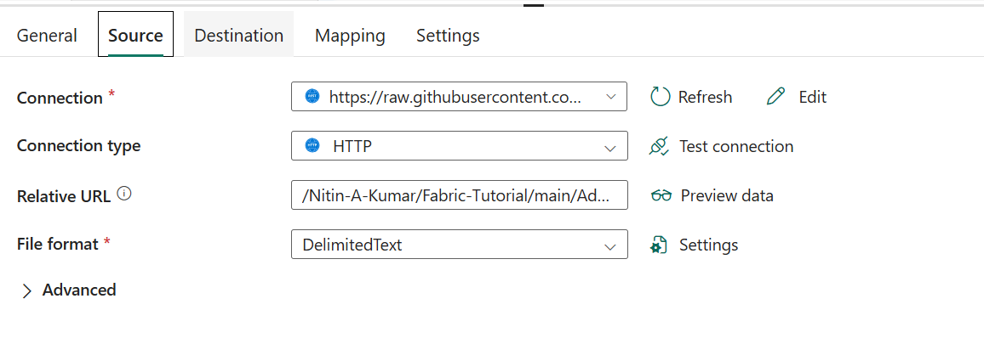

Destination

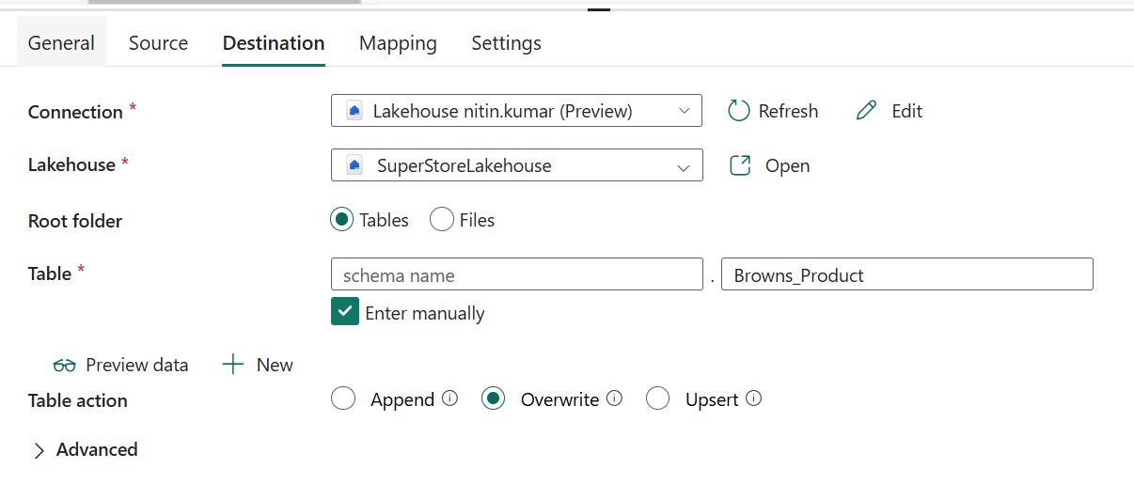

Git hub contain sales file for 3 year need to merge with append

Lookup setting –
@activity('Lookup FileName').output.value
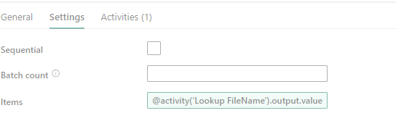

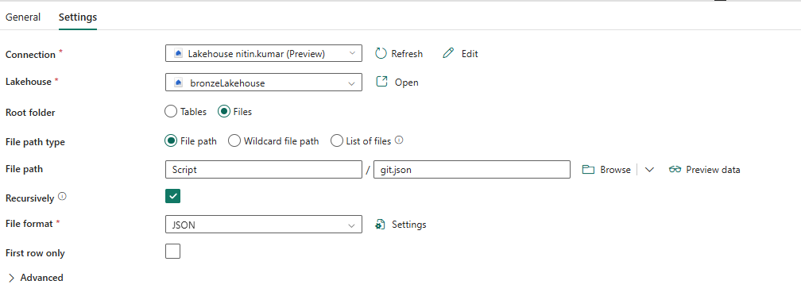
Solution in fabric use for each with copy data

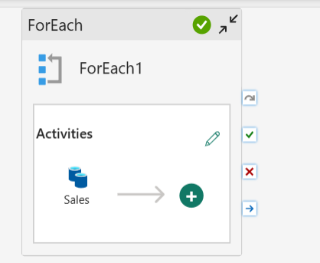
Foreach Setting-

Copy data setting
Source
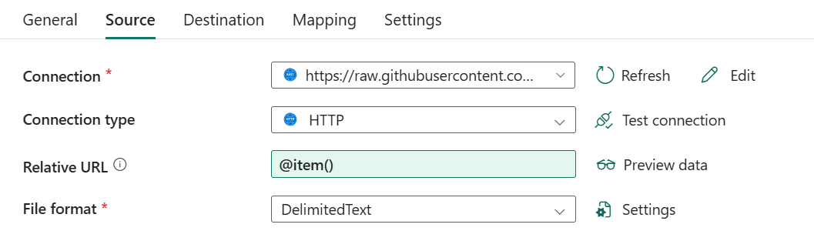

Destination
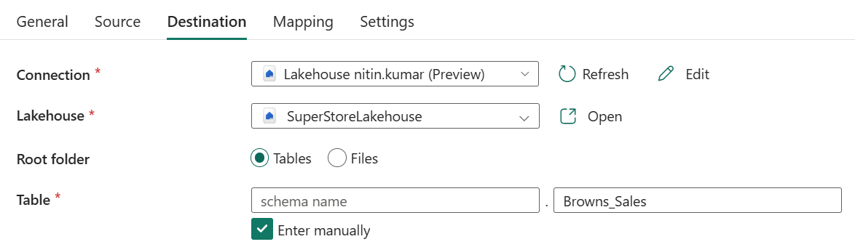

For each setting
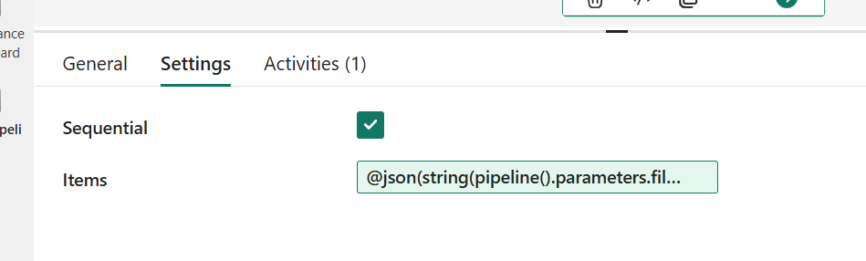

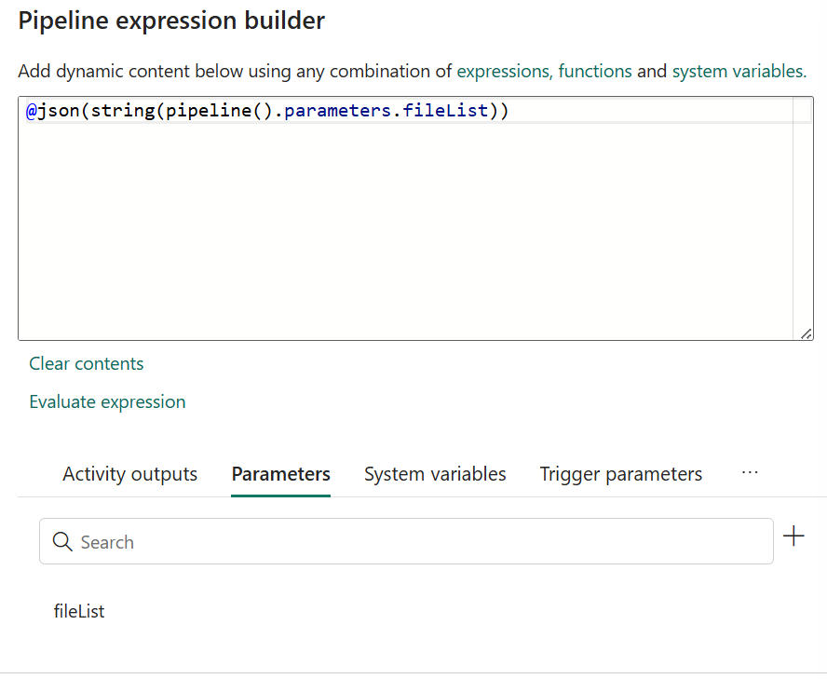

run the pipeline all data will be loaded directly and stored in lakehouse
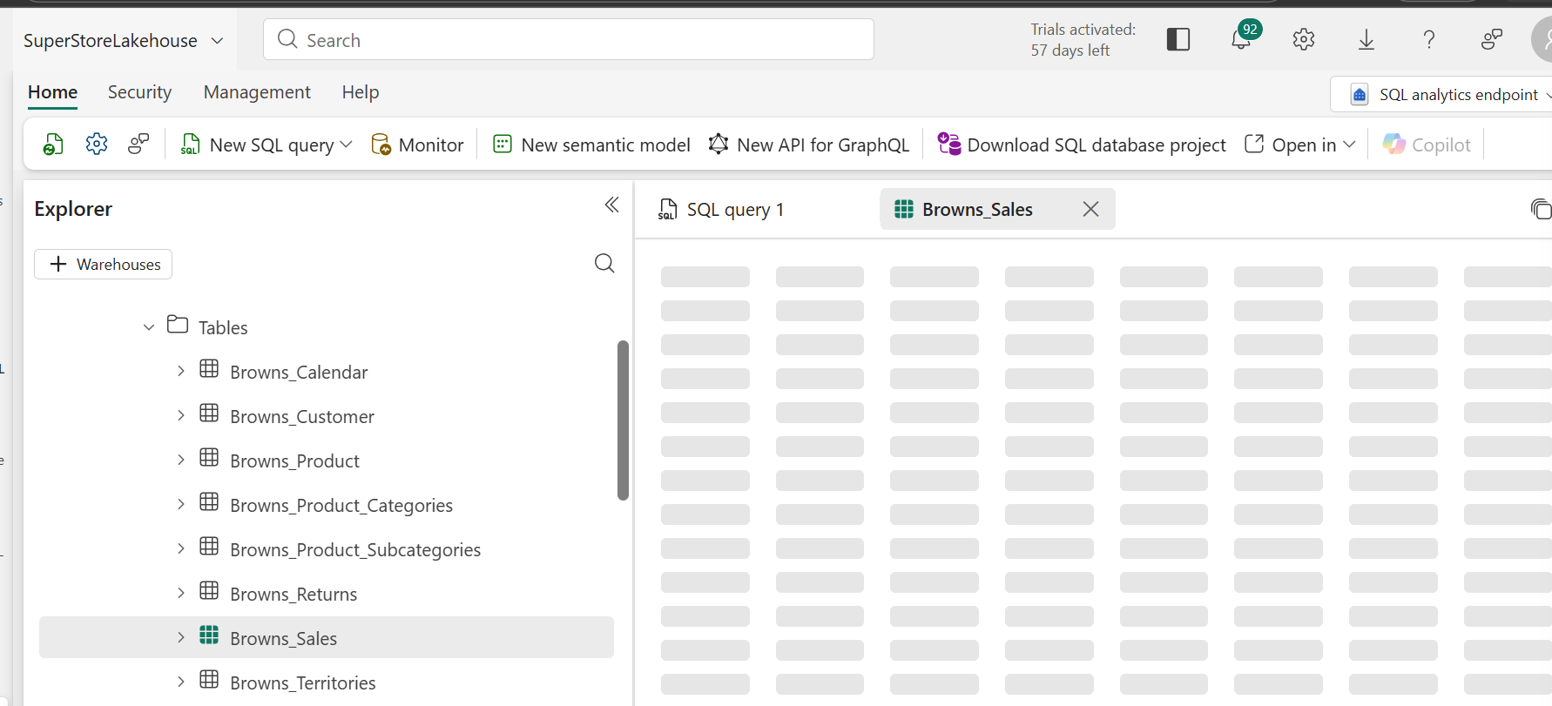

Incremental load using copy job / Merge or append option –
Merge-
Note – source table should be CDF chnagedatafeed =’True ‘ enabled and it should be enabled before creating table after creating table it will not be enabled
%%sql
CREATE TABLE CustomerData_CDF
TBLPROPERTIES (delta.enableChangeDataFeed = true)
Add- Copy Job
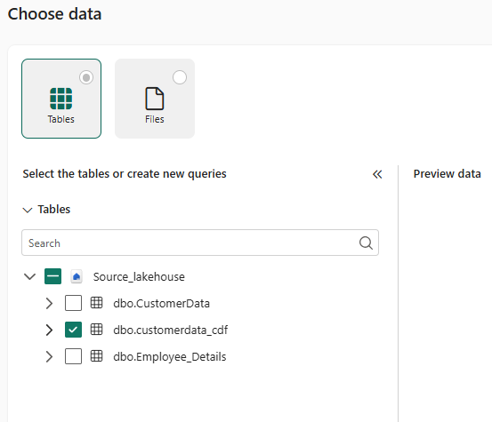

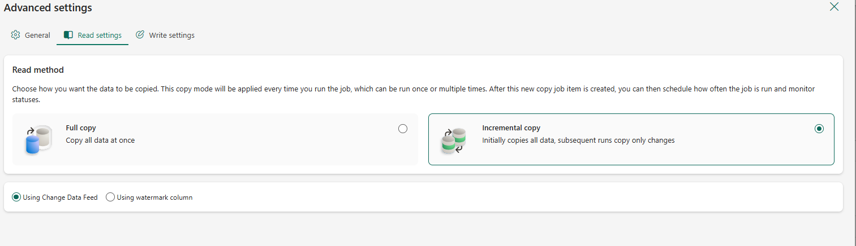
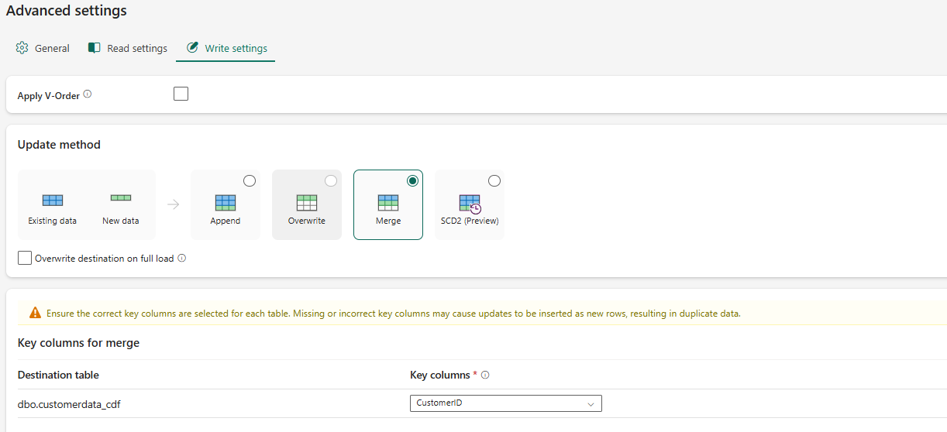
make a note – customer id is key row will not be duplicate if duplicate row then 2 row will be added same row should be updated if 2 row then first take latest row then create table then merge incremental load apply
SELECT *
FROM (
SELECT *,
ROW_NUMBER() OVER (
PARTITION BY CustomerId
ORDER BY ModifiedDate DESC
) AS rn
FROM Bronze_incremental_data
)
WHERE rn = 1;

------------Another method of incremental load
Source -
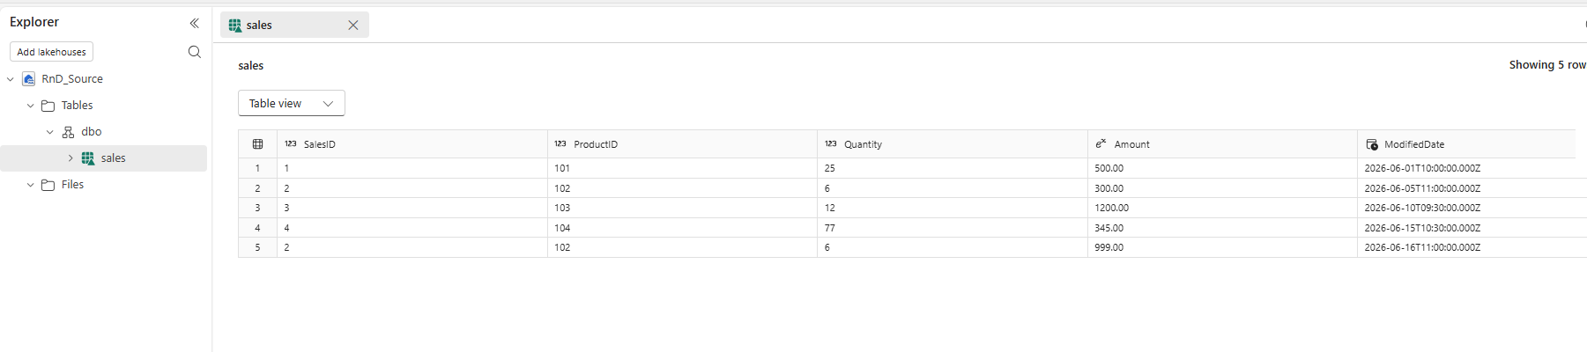
%%sql
CREATE TABLE Sales (
SalesID INT,
ProductID INT,
Quantity INT,
Amount DECIMAL(10,2),
ModifiedDate TIMESTAMP
)
TBLPROPERTIES (
'delta.enableChangeDataFeed' = 'true'
);
%%sql
INSERT INTO Sales
VALUES
(1,101,25,500,'2026-06-01 10:00:00'),
(2,102,6,300,'2026-06-05 11:00:00'),
(3,103,12,1200,'2026-06-10 09:30:00');

Push the data in target using copy -> deactive then create the pipeline flow
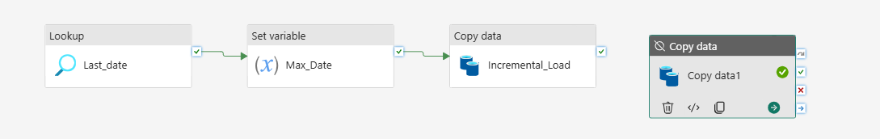

Lookup – it will take max modified date of target
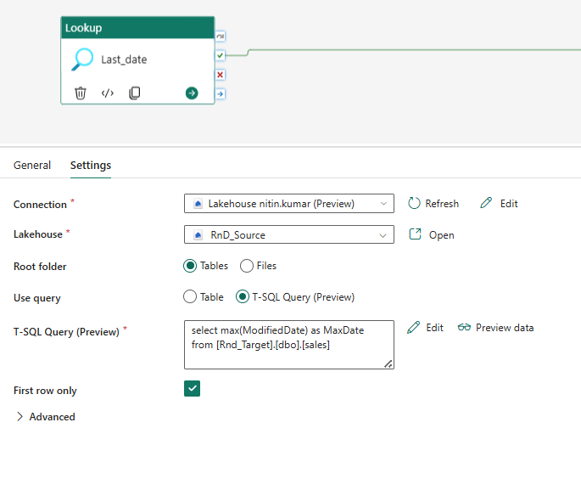

Variable – set mas value to variable
@activity('Last_date').output.firstRow.MaxDate

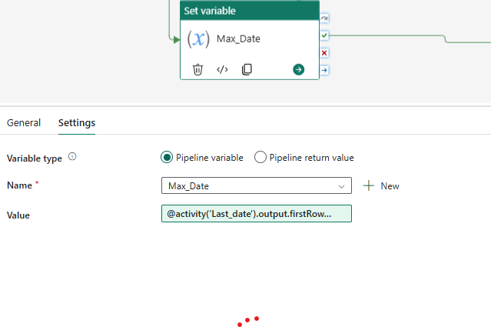

Copy data –

select * from sales
where ModifiedDate > '@{variables('Max_Date')}'
check condition before pushing data to to target in source

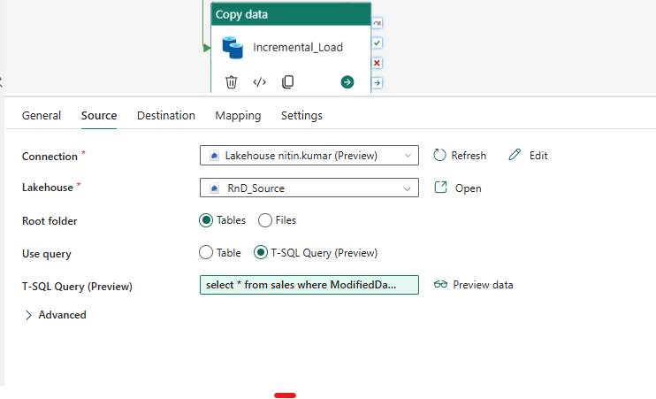
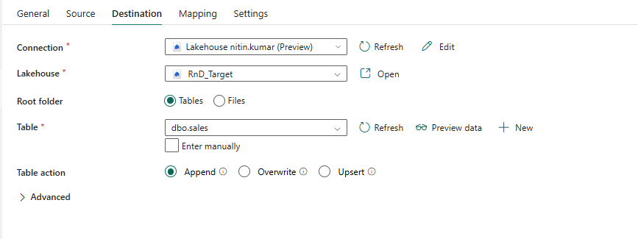

Senario – where source does not contain date then how to do incremental load
Ex- • CSV (no date column)
• Need incremental load ✅
• Using Fabric Lakehouse ✅
• Bronze → Silver ✅
CSV (Files) ↓ Notebook 1 → MERGE → Bronze ✅ ↓ Notebook 2 → MERGE → Silver ✅
HY THIS IS BEST
Problem | Solution
No date column | MERGE compares columns ✅
CSV source | Full read + compare ✅
Copy job errors | Removed ✅
CDF complexity | Avoided ✅
Incremental | Achieved via MERGE ✅
Notebook – Option1Notebook_incremental
# This is incremental load option 1 where trying to upload csv table > create table addting ingestion_date > do incremental load as a bronze table
from pyspark.sql.functions import *
from pyspark.sql.types import *
from delta.tables import DeltaTable
2.
df_src = spark.read.format("csv") \
.option("header", True) \
.option("inferSchema", True) \
.load("Files/Employee/Employee.csv")
display(df_src)
3. df_src = spark.read.format("csv") \
.option("header", True) \
.option("inferSchema", True) \
.load("Files/Employee/Employee.csv")
display(df_src)
4.
from delta.tables import DeltaTable
from pyspark.sql.functions import current_timestamp

table_name = "Incremental_Load.bronze_employee"

if spark.catalog.tableExists(table_name):

# ✅ MERGE (incremental)
delta_table = DeltaTable.forName(spark, table_name)

delta_table.alias("t").merge(
df_src.alias("s"),
"t.EmployeeId = s.EmployeeId"
).whenMatchedUpdate(
condition="""
t.EmployeeName <> s.EmployeeName OR
t.Region <> s.Region OR
t.Dept <> s.Dept
""",
set={
"EmployeeName": "s.EmployeeName",
"Region": "s.Region",
"Dept": "s.Dept",
"ingestion_date": "current_timestamp()"
}
).whenNotMatchedInsert(
values={
"EmployeeId": "s.EmployeeId",
"EmployeeName": "s.EmployeeName",
"Region": "s.Region",
"Dept": "s.Dept",
"ingestion_date": "current_timestamp()"
}
).execute()

else:
# ✅ First time load ONLY
df_src.withColumn("ingestion_date", current_timestamp()) \
.write \
.mode("overwrite") \
.format("delta") \
.option("delta.enableChangeDataFeed", "true") \
.saveAsTable(table_name)
Above will read csv file make upsert table in bronze table

Copy job – reach bronze table and load it with merge incremental load to target
CDF or watermark any one can be used
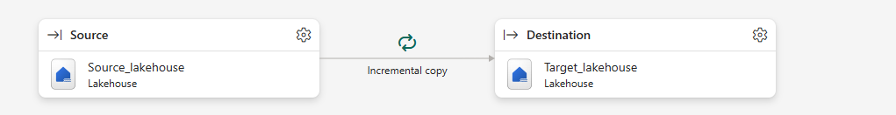
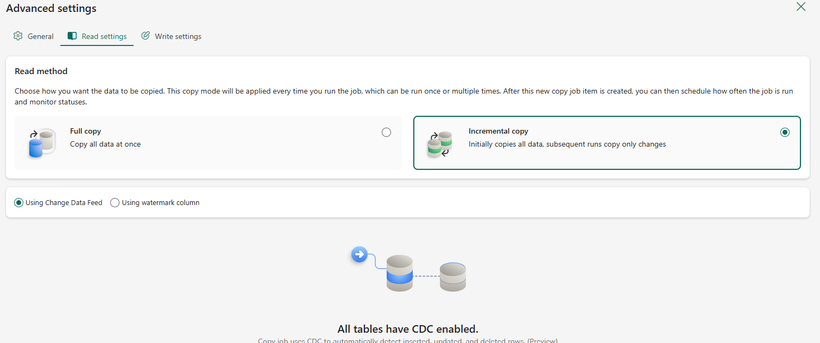

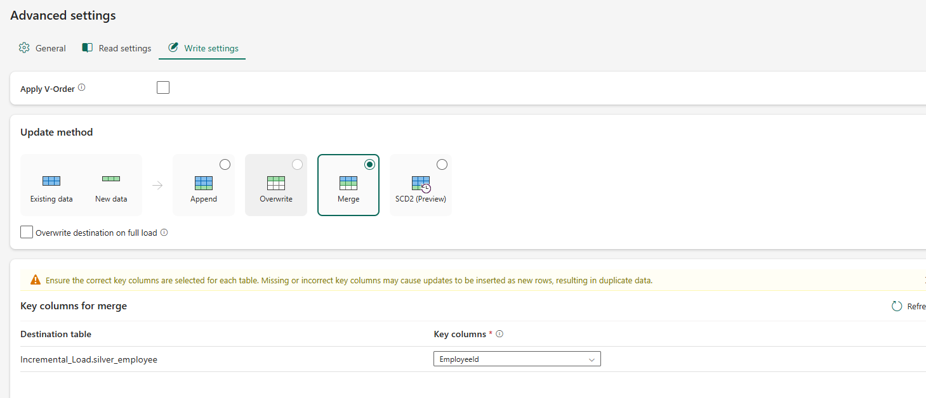

Make a pipeline for automate
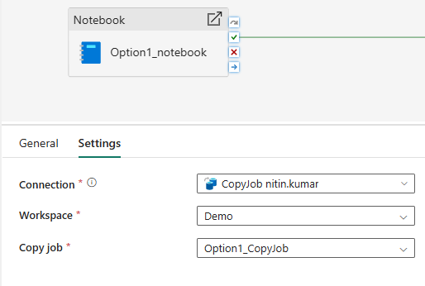
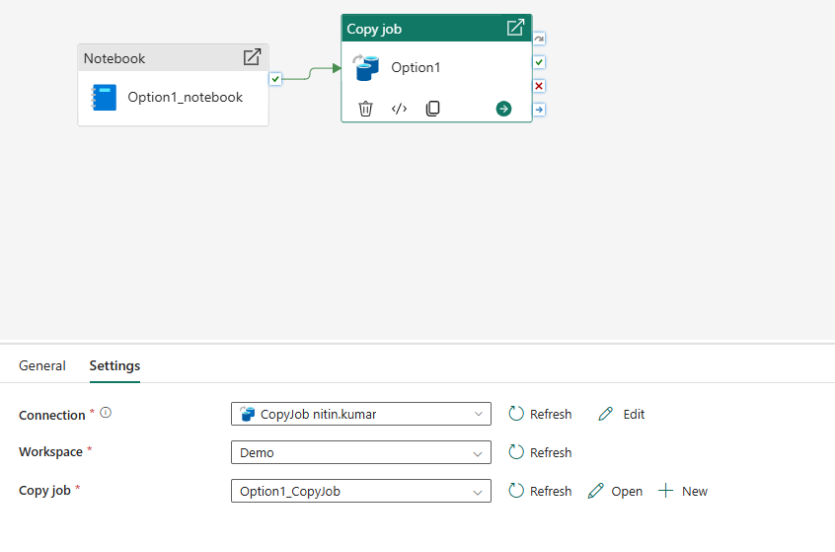

Requirement option 3 - Increment load requirement option 3 , incase file come on daily basis you want to load only increment data loaded how can you do it
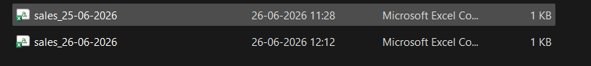
Sales files target sales table
- Create Lakehouse with folder sales
Lakehouse contain source and target table with
- # Option 3 with files and create metadata table to store file load details

from pyspark.sql.functions import *
from pyspark.sql.types import *

- Create meta data table what will capture metadata for file

spark.sql("""
CREATE TABLE IF NOT EXISTS processed_files
(
file_name STRING,
load_time TIMESTAMP
)
USING DELTA
""")

- Create target table in lakehouse
spark.sql("""
CREATE TABLE IF NOT EXISTS Target_Sales_data
(
order_id INT,
amount float,
file_name STRING
)
USING DELTA
""")

- Upload source file in sales folder then read it

df = spark.read.option("header",True).csv("Files/sales/")
df = df.withColumn("file_name",input_file_name())

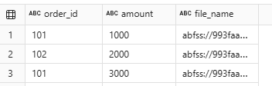

# Extract clean file name
df = df.withColumn(
"file_name",regexp_extract("file_name",r'([^/]+$)',1)
)

- processed_df = spark.sql("SELECT file_name from processed_files")
display(processed_df)
no data

new_df = df.join(processed_df,on='file_name',how='left_anti')
display(new_df)
What’s happening here:
- df → your new incoming dataset (the fresh files you just read).
- processed_df → the dataset of files you’ve already processed (from your Delta table).
- join(..., how='left_anti') → this is a special join type in Spark.

“Give me all the new files that haven’t been processed yet.”

• new_df will contain only the unprocessed files.
• If a file name already exists in processed_df, it will be excluded.
left_anti as a filter for “not in”. It’s Spark’s way of saying: “Give me everything in A that’s not in B.”

- update the table datatype as file is ket as string
new_df = new_df.withColumn("order_id",col("order_id").cast("int"))\
.withColumn("amount",col("amount").cast("float"))

- write data in the table
new_df.write.format('delta').mode('append').saveAsTable("target_sales_data")

- ## existing file name load to processed_file

## existing file name load to processed_file
existing_files = (spark.table("target_sales_data")\
.select("file_name")\
.distinct()\
.withColumn("load_time",current_timestamp())
)
existing_files.write.format("delta")\
.mode("overwrite")\
.saveAsTable("processed_files")
Create note book make it as as pipe line and schedule it

